“Wrapping Up the Year” Links from Presentation on 6-2-21
Copying citizenship video
https://screencast-o-matic.com/watch/crhZbcVhcki

Best Practices for ending the year -- Schoology: Compass Webinar Recording: Best Practices for Ending the Year Right on Vimeo
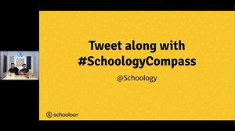   | Compass Webinar Recording: Best Practices for Ending the Year Right  You accomplished a lot this year - building courses, organizing groups - all towards an ultimate goal of teaching students. Even though the school year isn’t over, now is the best time to start preparing to wind things down. In this webinar we review all the most important things to know before ending the school year: - What to do about final ...  vimeo.com

Self-Paced Rollover Course Code Learn about best practices when it comes to closing out the year within Schoology Learning. Course Code BSGT-982T-WCQKJ

Success with Schoology Webinars Tips and Tricks for the Schoology Gradebook and
End-of-Year Recording and Slide Deck
Success with Schoology: Tips & Tricks https://support.schoology.com/hc/en-us/articles/1500007020801#h_01F5XR8RR60KHGRQWXYPTEKAFN

New Schoology Elementary Experience:
For more information and a tour of the Elementary Experience check out this video at the 9:27 mark. https://support.schoology.com/hc/en-us/articles/1500007017881-Schoology-Learning-2021-Product-Roadmap

